**Module 6: Multisensory Rooms**

**6C Sensory Rooms for Learners with Autism**

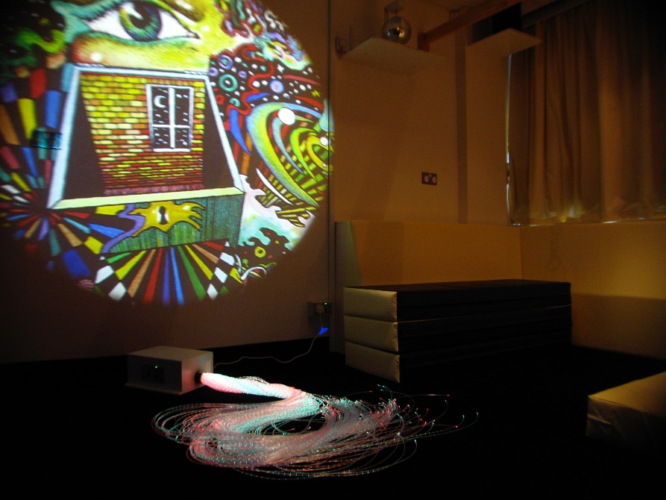

If you are creating a sensory room for learners with autism, you need to be able to increase and decrease stimulus, use inputs in isolation or in combination with something else. This flexibility is essential otherwise children may respond by getting distracted or overwhelmed.

The room needs to be a blank canvas without immediate, inbuilt distractions such as obvious switches and opening cupboards. It is very important not to enter the room and immediately switch all possible equipment on. Equipment can be out of reach or portable so it can be brought in when a practitioner needs to use it. Complexity should be kept to the minimum to stop the child being overwhelmed and in order to gauge and react to response.

Spatial awareness can be supported by colour contrast. Avoid mirrors unless they are small and portable and used with a clear focus. Sensory rooms can be very effective in moments when calming or self regulation are needed. Having controllable stimulus enables a personalised and differentiated response.

**What equipment:** projection (ipad or wheel), portable fibre optics so can be removed, fixed bubble tube a good idea so object of reference for learner, any spinning lights particularly hand held, good quality sound that can easily be adjusted.